DATA ANALYSIS – a how to guide
Data analysis is a key skill in most science assignments – including experiment reports and research assignments. All data is unique and analysis of data is therefore sometimes very difficult. However, there are some key similarities in the analysis of all data, and these similarities are presented here.
There are four key and common stages in data analysis. These are in order:
Identifying the trends in the data
Identifying the uncertainty and the limitations in the data
Making conclusions.
Evaluating the reliability and the validity of the conclusions
Each of these stages is in all science research reports, and they therefore play a major role of science reports in our senior school. Each of these sounds complicated, but can be explained as a simple step by step process you need to follow when examining data. Once you understand the process of data analysis, you can practice it and easily become a Jedi data master.
On the following pages is a step by step guide to each of the stages of data analysis.
Identifying and describing Trends and Relationships.
Generally speaking trends and relationships are the same idea. “Trend” or “trend line” is used a lot when identifying or describing the line of best fit on a graph. Relationship is a broader term, and can be used instead of trend, but also has a wider range of use. Both words can be used to identify or describe how the dependent variable (on the y axis) and the independent variable (on the x axis) are connected to each other. However the word relationship is more useful when talking about the maths that connects two variables.
There is a very simple way to ensure you do a good job identifying trends and relationships – simply follow the steps below.
- Start with the “most important” trend, then work through to the least important. All trends need to be relevant.
- Write a para for each trend you can see. Each graph probably has a trend, and if you have more than one graph, there may be trends across several graphs.
- For each paragraph, follow the same sequence of argument. See next bullet for each para.
- Starting each paragraph with a very simple sentence identifying the trend in the data. The sentence should go along the lines of…
“As the (independent variable) increases, the (dependent variable) increases/decreases (use which ever applies)”.
- The second sentence is a description of the trend. This can be simple, or more complex, depending on the data (shape of the trend line), and how smart you are. Describe the trend as linear, exponential, polynomial, power, or logarithmic. A brief description of each of these is shown below.
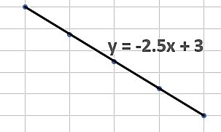
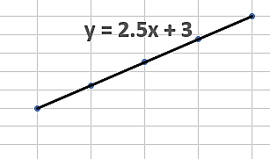
- Linear. A linear trendline is when the dependent variable is increasing or decreasing at a constant/steady rate as the independent variable increases. If the trend line is straight AND goes through the zero/zero point the change in the dependent variable is proportional to the change in the independent variable. The slope is the rate of change, and you should quote the slope as part of your description, and explain it. The intercept on the y-axis can also have meaning, if this is the case. State the y-axis intercept, and describe its significance.
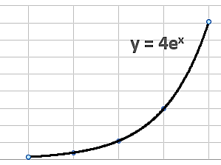
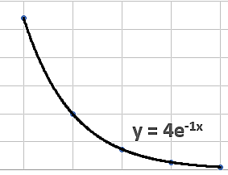
- Exponential. An exponential trendline is a curved line where the dependent variable values rise or fall at increasingly higher rates. Describe the shape of the curve in words.
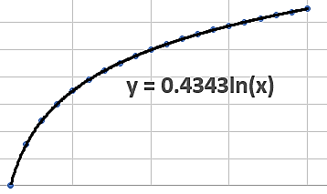
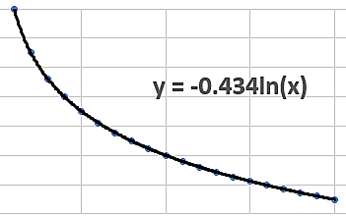
- Logarithmic. A logarithmic trendline is a curved line where the rate of change in the data increases or decreases quickly and then levels out. Describe the shape of the curve in words.
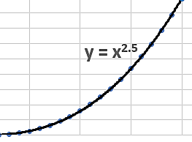
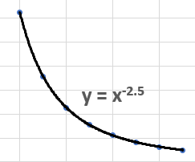
- Power. A power trend line (or index line) is very similar to the exponential curve, only it has a more symmetrical arc, and often you have to look at the math equation to identify the difference. Scientists often use the term exponential to describe a trend which is actually best described by a power trend line. Mathematicians would be horrified by this mistake. Describe the shape of the curve in words.
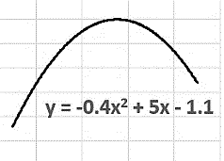
- Polynomial. A polynomial trendline is a curved line where the data goes up and down. This is useful for complex data, say in biology where there is seasonal variation in the data. Describe the shape of the curve in words.
- The rest of your paragraph will be used to quote data from the table or graph which supports the identification and description of the graph.
- At the end of the paragraph you can explain any specific implication of this trend. Your trends may not have a specific implication, especially if they are simple trends like linear trends.
Identifying Uncertainty and Limitations.
Uncertainty is a word which describes how certain you are that your data is precise. This does not mean how accurate your data is, just how certain you are that the data was measured correctly.
- Start this section with a simple statement stating the amount of uncertainty in the data. Something along the lines of “There is a (use an appropriate word) amount of uncertainty in the data”. For the rest of the paragraph, you need to justify this statement by explaining how you determine the uncertainty – see next bullet point.
- There are three ways to identify the amount of uncertainty in the data (assuming you have not calculated it yourself). You need to apply all three ways. There is uncertainty in the data if only one of these ways identifies it.
- The first way to identify uncertainty is from the data values. Sometimes the data values may be written an additional ± value beside them. This can be shown on a graph as lines which extend out from the data points. This extra ± value is the uncertainty the scientists (or you) calculated was in the data. Generally speaking, an uncertainty which is higher than five or ten percent (do the percent calculation if it is not shown) is considered to be significantly uncertain. In some situations where it is very difficult to measure values – such as health effects in humans - uncertainty can be higher and the data still consider reasonably certain.
- The second way to identify uncertainty is to see if there was data which was not used in the final results. Scientists sometimes label or discuss data in the trials which they consider outliers, and often label them anomalies. These anomalies are not used to calculate averages. This means the anomalies do not show in the final set of results. Because the anomalies have been removed, the final data set can seem to have low uncertainty. However, the fact that there are anomalies in the raw data means there is uncertainty in the data.
- The third way to identify uncertainty is by looking at the data and the trendline on a graph. Data points which are very close to a trend line suggests that the trend is very consistent, and that there is low uncertainty in the data. If the data points are not close to the trend line, the trend is not consistent, and that there is a significant amount of uncertainty in the data. The degree to which the data matches the trend line is measured by the R² value in excel. R² is a very precise term however, so do not use it to say your data is accurate.
Limitations are things which mean your experiment process did not necessarily measure what it was intend to. Almost all data contains limitations, you just have to identify them and explain what they are.
- Start this section with a simple statement along the lines of “ There appear to be (use an appropriate word) limitations in the data”. For the rest of the paragraph, you need to identify and briefly explain each limitation – see next bullet point.
- There are three ways to identify the limitations. You need to apply all three ways. Only discuss the limitations you find, although if you cannot identify any, you do need to explain this.
- The first way to identify uncertainty is to look at how much data was measured. Generally speaking there needs to be 5 variations of the independent variable, and three trials for each variation. Five variations of the independent variable means there will be five data points on a graph – which is the minimum to use to accurately identify a trend. If there is less than five data points on the graph the data is limited in its ability to identify a trend. If there are no trials and no averages used, the data is also limited in its precision.
- The second way to identify limitations is to look at the value of the independent variable. Sometimes this is not a real-life value, but one the scientist used so the experiment/investigation could be completed in a shorter amount of time. Say a scientist was measuring the rate of decay in human skeletal remains – which may take many years to do in real life conditions. Scientists will often use an independent variable which is not real-life (for example - tiny bone fragments rather than whole bones) to speed things up. This is not “wrong”, and perfectly justified in science, but it can limit how well the data applies to real life conditions.
- The third way to identify limitations is by identifying any controlled variables which were not actually controlled. All controlled variables should be kept constant so that it is only the independent variable causing the change in the dependent variable. Sometimes the controlled variables cannot be kept constant, or were not kept constant. This is quite common in health studies in humans. Studies which investigated the effect of smoking on lung cancer had to try and control all the other factors which cause lung cancer control. Controlling variables is practically impossible when studying long term health risks in humans. If controlled variables were not well controlled, this limits the accuracy of any trend which has been identified.

Conclusions.
The conclusion section is usually relatively short. Each conclusion has its own paragraph, and each paragraph follows the same sequence. The first paragraph has to be the main conclusion made from the data, followed by one paragraph each for the less important conclusions.
- Start each paragraph with a simple statement of the actual conclusion you have made.
- Follow this statement with a description of the trend supporting the conclusion. If you have a mathematical equation, include it here to support your opening statement. If you do not have a mathematical equation, elaborate and further explain your conclusion or the trend which supports it.
- Explain the real-life implications of the conclusion. That is, explain how this conclusion is relevant and important. Doing this generally shows you understand the significance of the conclusion.

Evaluation of reliability and validity
This sounds complicated, but is actually quite easy. It is easier if you discuss reliability separately from validity, so do this in two parts.
Reliability generally refers to whether your data is repeatable. That is, if anyone else was to do the investigation using the same method, would they get the same result? You do not have to guess this, as the uncertainty you identified earlier can be used here. If your have identified any uncertainty, the method is not reliable. If you were unable to identify any uncertainty, then the data is reliable. Reliability should only take one paragraph, and there is a sequence you can follow for this paragraph.
- Start the paragraph by stating if the method and resultant data is reliable, not reliable, or somewhere in between. Then justify this by explaining the uncertainty you identified earlier. Then try to identify why that uncertainty occurred by evaluating the errors made in the method. This last bit is the hard part.
Validity generally refers to whether the trends you identified, and the conclusions you made are valid or not. That is: are the trends real, and are the conclusions meaningful? Again, you don’t have to guess this as the limitations you identified earlier can be used to argue validity. There is also one additional way to evaluate validity. This is by comparing your conclusions to existing theory and determining if there is error in your conclusion – traditional error analysis. Evaluating validity should also only take one paragraph, and the sequence you should follow is outlined below.
- Start the paragraph by stating if the conclusions made in the investigation are valid, not valid, or somewhere in between. To justify this, start with determining the amount of error in the conclusion. This is easy if your conclusion is a value and can be compared to a “known” value – determine the percent difference between the two values ( $\% error= \frac{|\exp{value-known value|}}{known value} ×100$). Obviously, if there is a low percentage error, your conclusion is valid; and vice versa. If the conclusion cannot be compared to a “known” value, you can still argue whether there is error by comparing it with existing theory. If your conclusion contradicts an existing and well accepted theory, you may have significant error and your conclusion may not be valid – or it is valid, and everyone else is wrong! Once you have dealt with error, use the limitations you identified earlier to justify if the conclusion is valid. Explain how that limitation could have been avoided.

